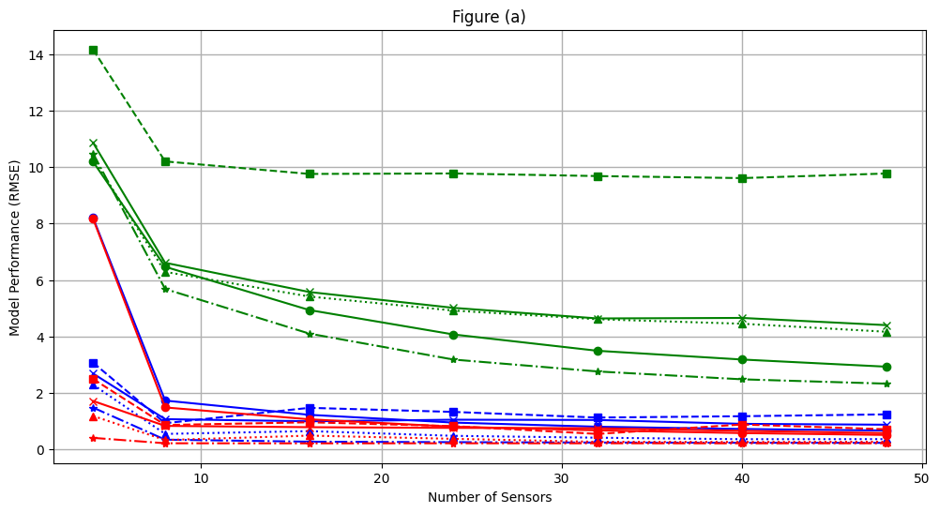

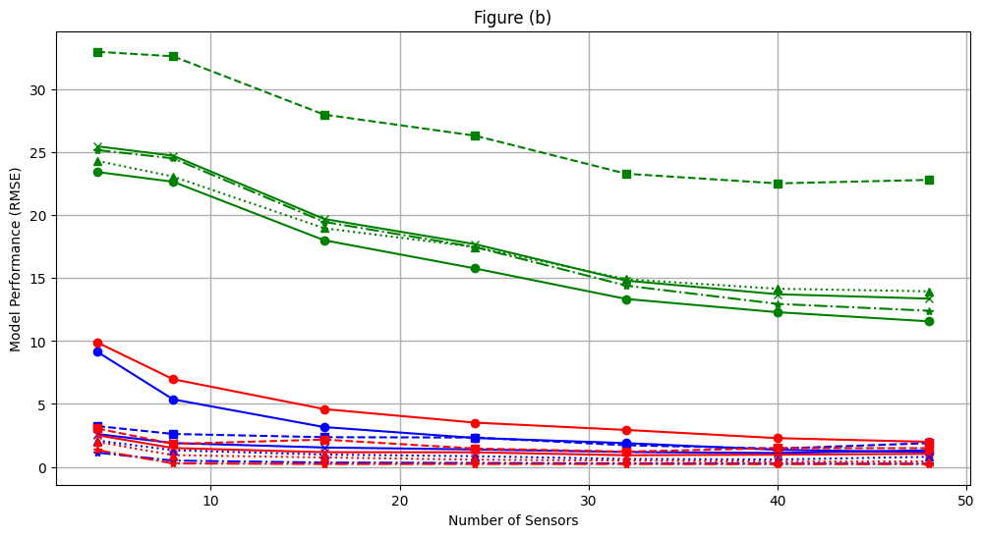

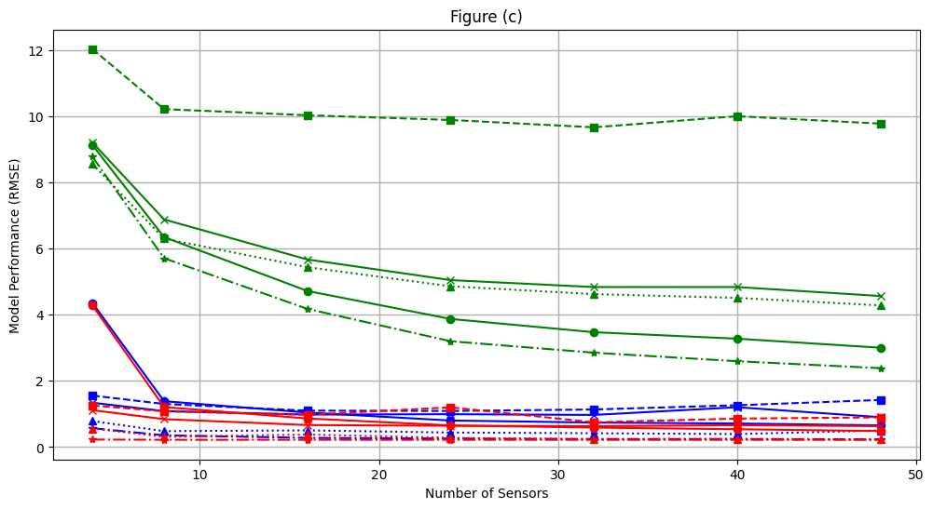

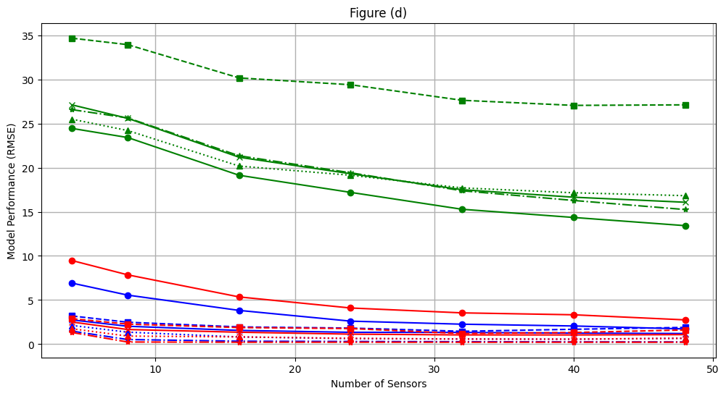

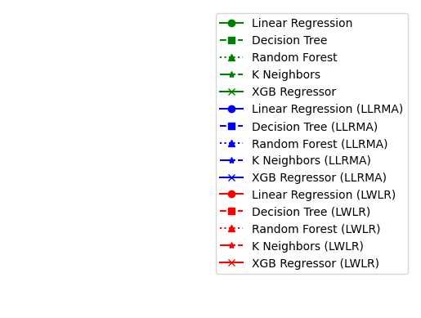

**Figure (a):** Comparison of UWB Model Performance on Sensor topology F for Different Sensor Configurations

**Figure (b):** Comparison of MICS Model Performance on Sensor topology F for Different Sensor Configurations

**Figure (c):** Comparison of UWB Model Performance on Sensor topology C for Different Sensor Configurations

**Figure (d):** Comparison of MICS Model Performance on Sensor topology C for Different Sensor Configurations